

Management & Science University

University Drive, Off Persiaran Olahraga

Section 13, 40100 Shah Alam

Selangor Darul Ehsan

**THESIS MANAGEMENT & EVALUATION SYSTEM**

(THEMES)

USER MANUAL for STUDENT

Version 1.0

Document Reference: MSU/THEMES/UM/004

**DOCUMENT DETAILS**

|  |  |
| --- | --- |
| **Effective Date:** | 1st June 2015 |
| **Document Owner:** | Information Technology and Innovation Centre (ITIC) |

**REVISION HISTORY**

|  |  |  |  |
| --- | --- | --- | --- |
| **Date** | **Version** | **Description** | **Author** |
| 18th February 2015 | 0.1 | Document creation | Zuraimi, Amalina |
| 02nd March 2015 | 0.2 | Document review and update | Zuraimi |
| 19th May 2015 | 1.0 | Final | Zuraimi, Nizam |

**TABLE OF CONTENTS**

1 INTRODUCTION 1

1.1 Scope 1

1.2 System Requirement 1

1.2.1 URL 1

1.2.2 Internet Browser 2

1.2.3 User Access 2

1.3 Screen Design 2

2 HIGHLEVEL FLOW 4

2.1 Thesis Proposal Submission Process Flow 4

3 USER LOGIN and LOGOUT 5

3.1 Login 5

3.2 Logout 5

4 CHANGE PASSWORD 6

4.1 Change Password 6

5 THESIS VIEW 7

5.1 Search Student via Thesis ID/Title 7

5.1.1 Student Profile Details 7

5.2 Search Student via Student Name/Matrix No 10

5.2.1 Student Profile Details 10

6 LIST OF APPROVED THESIS 14

6.1 List of Approved Thesis 14

6.2 Generate File 15

7 ADMINISTRATION VIEW 16

7.1 Thesis Approval 16

7.2 Thesis Approval – Next Section 17

17

7.2.1 Enter Remark 19

7.2.2 Change and View Supervisor/Co-supervisor 20

7.2.3 Upload Attachment 23

6.3 List of Thesis Proposal – Disapproved Thesis by Senate 23

6.3.1 Generate File 24

Appendix 26

Thesis Proposal – Approved (Student) 26

Thesis Proposal – Disapproved (Student) 27

Thesis Proposal – Approved with Changes (Student) 28

Thesis Proposal – Approved (Faculty) 29

Thesis Proposal – Disapproved (Faculty) 30

Thesis Proposal – Approved with Changes (Faculty) 31

Invitation as Supervisor/Co-Supervisor 32

**LIST OF FIGURES**

Figure 1: PGTMCS Screen Structure Design 3

Figure 2: Thesis Proposal Submission Process Flow 4

Figure 3: Login Page 5

Figure 4: Logout Page 5

Figure 5: Change Password Page 6

Figure 6: Thesis Tab 7

Figure 7: Student Profile 8

Figure 8: Subject Taken 9

Figure 9: Thesis History 9

Figure 10: Thesis Tab 10

Figure 11: Student Profile 11

Figure 12: List of Supervisor / Co-Supervisor 11

Figure 13: Subject Taken 12

Figure 14: Thesis History 13

Figure 15: List of Approved Thesis 14

Figure 16: List of Approved Thesis PDF 15

Figure 17: Thesis Approval 16

Figure 18: Thesis Approval - Searching Result 17

Figure 19: List of Thesis for Senate Approval PDF 18

Figure 20: Remarks by Senate 19

Figure 21: Change Supervisor/Co-Supervisor 20

Figure 22: Search Result with no searching criteria provided 20

Figure 23: Search Result with searching criteria provided 21

Figure 24: List of Assigned Supervisor 21

Figure 25: View and Update Supervisor Biodata 22

Figure 26: View Supervisor Assigned 22

Figure 27: Upload Attachment 23

Figure 28: List of Thesis proposal - Disapproved 23

Figure 29: List of Disapproved Thesis by Senate 24

# INTRODUCTION

Thesis Management and Evaluation System (THEMES) version 1.0.0 is a system for the Student, Supervisor, Faculty and Senate to monitor the status of thesis proposal from its initial stage toward to the end. It is not only use by the respective personnel to control and manage the quality of the thesis to meet the university standard but it also can be used to keep track all the communication between the student and university. If required the history can be retrieved to view the completed work or its progress.

The system contains the main modules which are Thesis Proposal Submission and Approval, Monthly Progress Report Review, Thesis Proposal Defense, Thesis Work Completion, Thesis Evaluation/Viva and Senate Endorsement.

## Scope

The manual will guide the student on how to use the system in every stages starting from the thesis proposal submission, monthly report submission, defence proposal submission, work completion submission, viva evaluation and senate endorsement.

The manual is structured into the following sections:

| **Manual Section** | **Description** |
| --- | --- |
| Prerequisite | This section describes the actions or steps shall be done and in place first before the required steps can be done. |
| Steps | This section describes the steps to follow in order to yield the result for the desired function. |
| Next Action | This section describes the expected next steps to be followed once the above steps have been successfully performed. |
| Warning | This section describes the expected warning triggered by the system if the steps performed violate the business rule validation. |
| Note | This section describes the additional information which may be useful to the user while using the system. |

Figure 1: Manual Structure.

## System Requirement

### URL

The system is available over the internet via the URL <http://themes.msu.edu.my> and accessible only by the registered and authorized postgraduate student and respective MSU’s staff.

### Internet Browser

It is recommended to run the system on the following internet browser

* Mozilla Firefox version 35 and above
* Microsoft Internet Explorer version 8 and above

### User Access

The postgraduate students who have been successfully registered in Campus Management System (CMS) aka KLAS2 will be automatically become THEMES user or otherwise the student needs to check with the CMS admin on his/her credential status. By default the Student Matrix Number will be the user id to access the THEMES system.

The MSU’s staff that has been identified as reviewer, supervisor or co-supervisor can access the THEMES system once the THEMES admin registered him/her into the system. By default Employee ID will be the user id to access the THEMES system.

## Screen Design

The THEMES system screen has been design into the 5 sections namely section A, B, C, D and E.

Section A to contain the THEMES **Header** in which it contains the name of the system, the user name and Logout button

Section B to contain the THEMES **Top Panel** in which it contains the list of functions for the system.

Section C to contain the THEMES **Left Panel** in which it contains the list of sub-functions resulting from the selection in Section B.

Section D to contain the THEMES **Working Area** in which it shows the page for user respond resulting from the selection in Section C.

Section E to contain the THEMES **Footer** in which it contains the university name and its copyright.

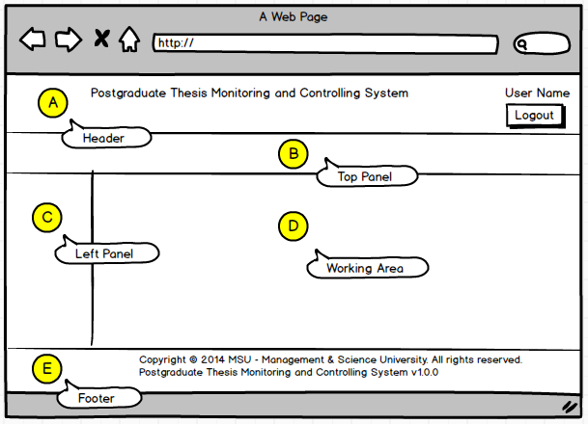

Figure 2: THEMES Screen Structure Design

# HIGHLEVEL FLOW

## Thesis Proposal Submission Process Flow

The figure below depicts the highlevel process flow for the thesis proposal submission which cover from the submission until its get approved by the Senate.

The dotted line as shown below is the focus covered in this manual.

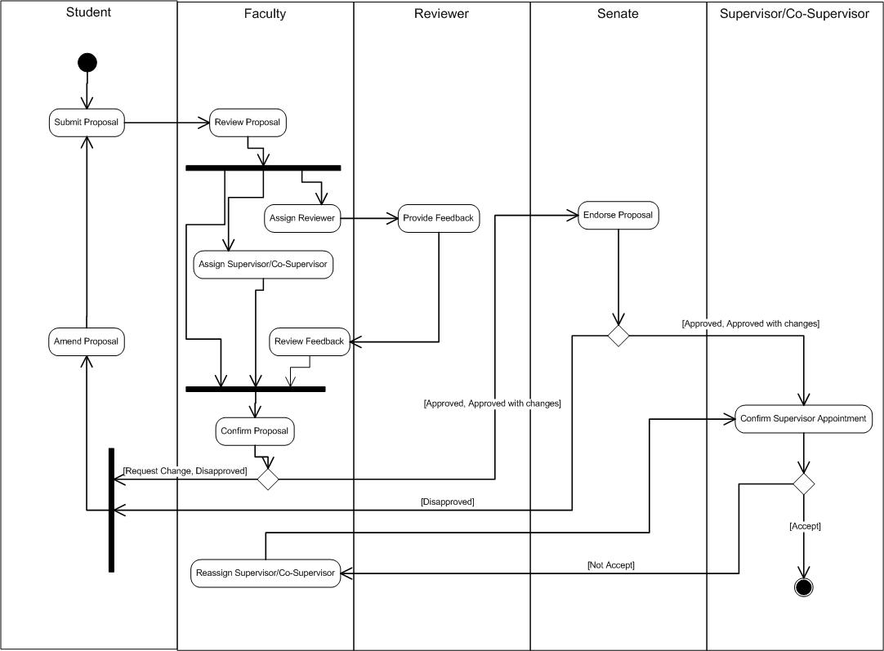

Figure 3: Thesis Proposal Submission Process Flow

# USER LOGIN and LOGOUT

## Login

This is the first page sight by the student to enter the PGTMC system.

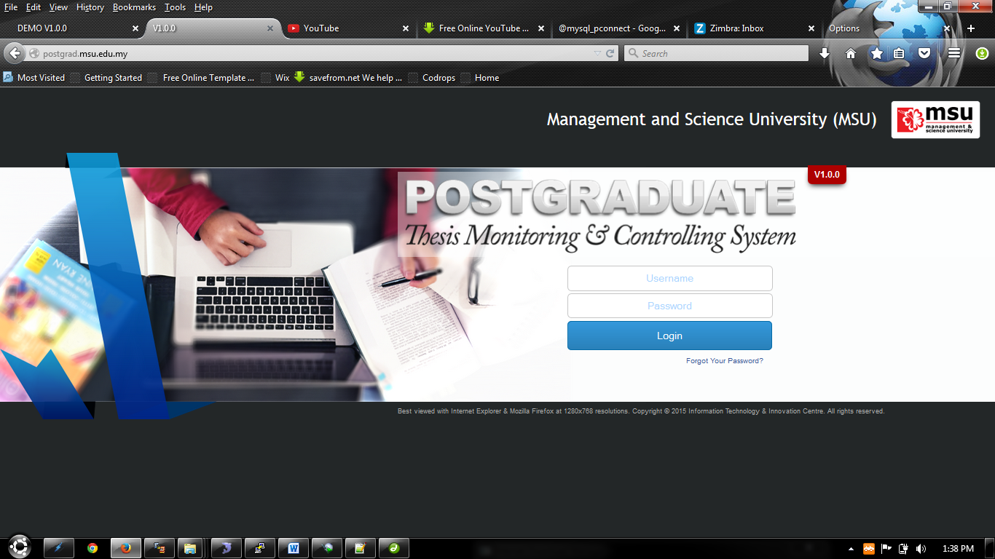

Student need to **login** Postgraduate Thesis System to create a New Proposal.

Figure 4: Login Page

**Steps:-**

1. Open any Internet Browser of your choice either Mozilla Firefox or Microsoft Internet Explorer
2. Enter the URL to access the system as follows <http://postgrad.msu.edu.my/>
3. Login page will be displayed in which the valid user credential needs to be provided i.e. **Username** and **Password**.

## Logout

Once the necessary or required activities has been done or completed, the student can quit from the system by clicking on the **Logout** button.

If the system is keep idle for about 1 minute, the system will logged out the user automatically.

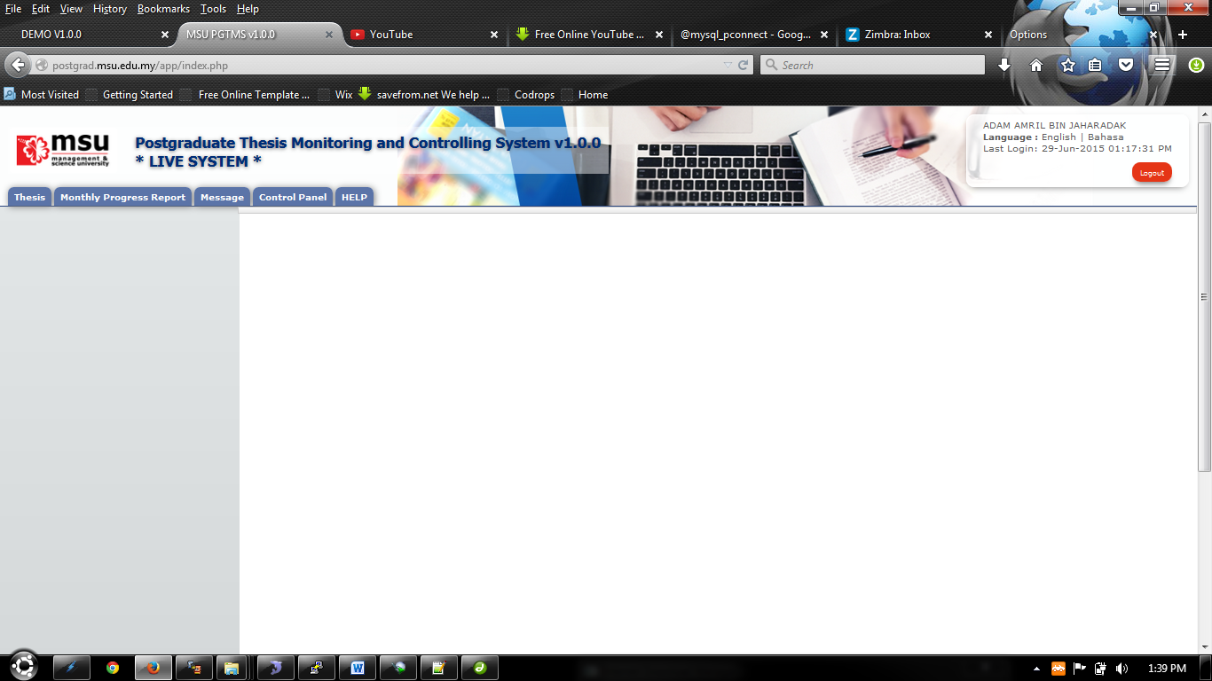

Button **Logout**.

Figure 5: Logout Page

**Steps:-**

1. Find the **Logout** button located on the right top corner of the system **Header** section.
2. Click on it and you will be logout from the system successfully.

# CHANGE PASSWORD

## Change Password

For the security reason, the user is strongly recommended to change the password at first successful login to the system.

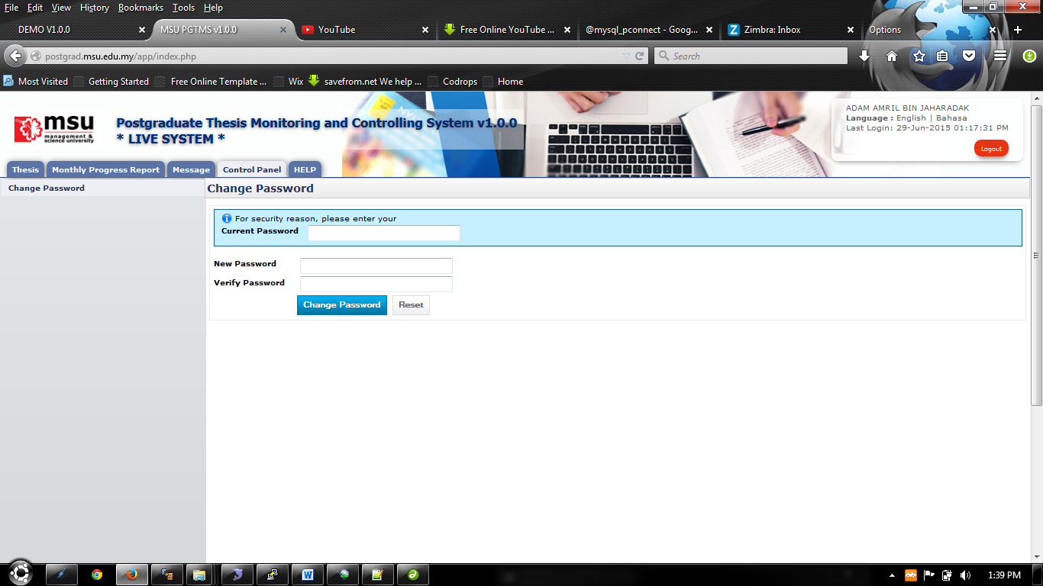

Figure 6: Change Password Page

**Steps:-**

1. Click on the **Control Panel** tab from the system **Top** panel section.
2. The **Change Password** menu will be displayed and click on it.
3. As to ensure the right user able to change the password, the system will ask **Current Password** used before able to change it to the new password.
4. Once the **Current Password** has been provided, the **New Password** and **Verify Password** can be provided afterward.
5. Click **Change Password** button to ensure the new password can be saved into the system successfully.
6. If the **Current Password** is incorrect, the system will prompt an error message and the user needs to redo the same steps above.
7. User can use **Reset** button if wanted to clear the entry on each fields.

# THESIS VIEW

## Search Student via Thesis ID/Title

Student profile can be retrieved via student’s **Thesis ID or Title**

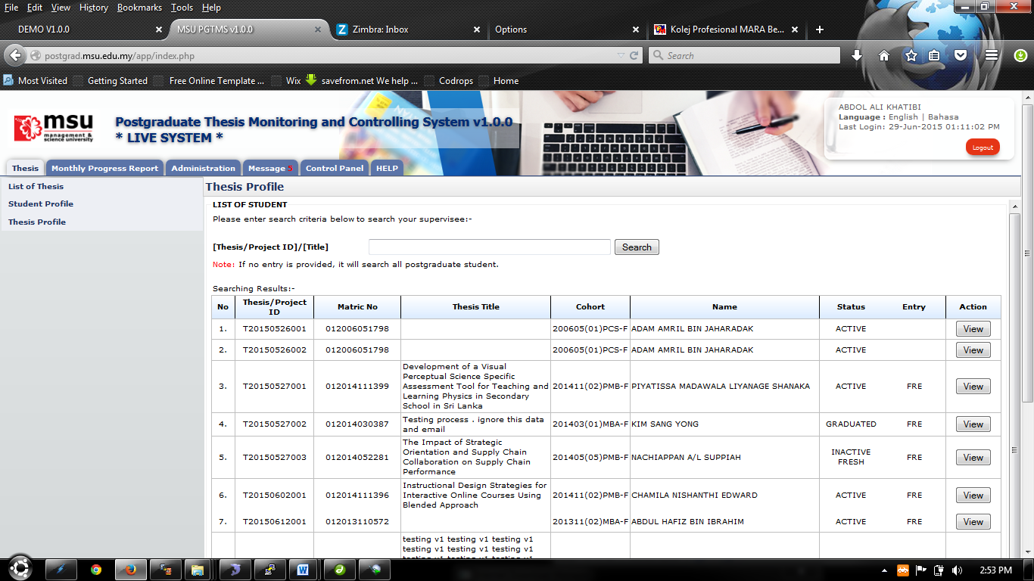

Figure 7: Thesis Tab

**Pre-condition**

1. none

**Post-condition**

1. View student profile
2. Proceed to administration view

**Steps:-**

1. Click on the **Thesis** tab on the system **Top** panel section.
2. The **Student Profile** menu will be displayed on the system **Left** panel and click on it.
3. The searching page will be displayed which the user can search for a particular thesis in order to view its detail
4. Enter the **Thesis ID** or **Title**. into the field and click on **Search** button to search the thesis
5. The record will be displayed under the search result.
6. Locate the student from the list and click **View** button to view the profile details

### Student Profile Details

Student Profile will contain all information that related to students which are Student Profile, Supervisor/Co-supervisor lists, Subject Taken and Thesis History.

#### Student Profile

Student Profile tab contains the basic student and thesis information including its thesis progress status

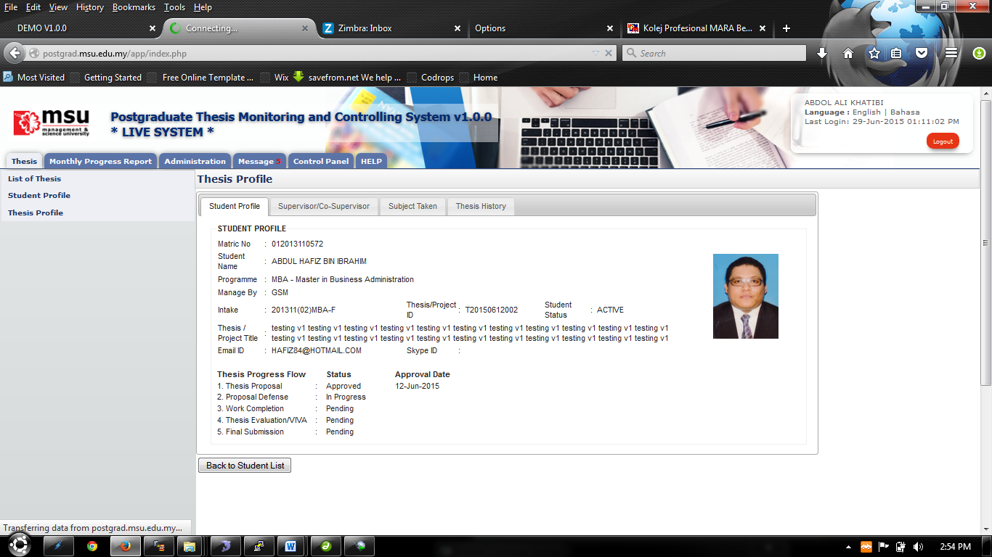

Figure 8: Student Profile

**Steps:-**

1. It is only for view information.
2. Click **Back to Student List** button to return back to **Student List** search page

#### Supervisor/Co-Supervisor List

Supervisor or Co-Supervisor is the academic staff who has been assigned by Faculty to supervise the student in delivering the thesis and approved by the Senate.

There are conditions for the student to see the list of his/her supervisors. The conditions are:-

1. Supervisor/Co-Supervisor has been assigned by Faculty and approved by the Senate
2. Supervisor/Co-Supervisor has accepted the appointment to supervise the student.

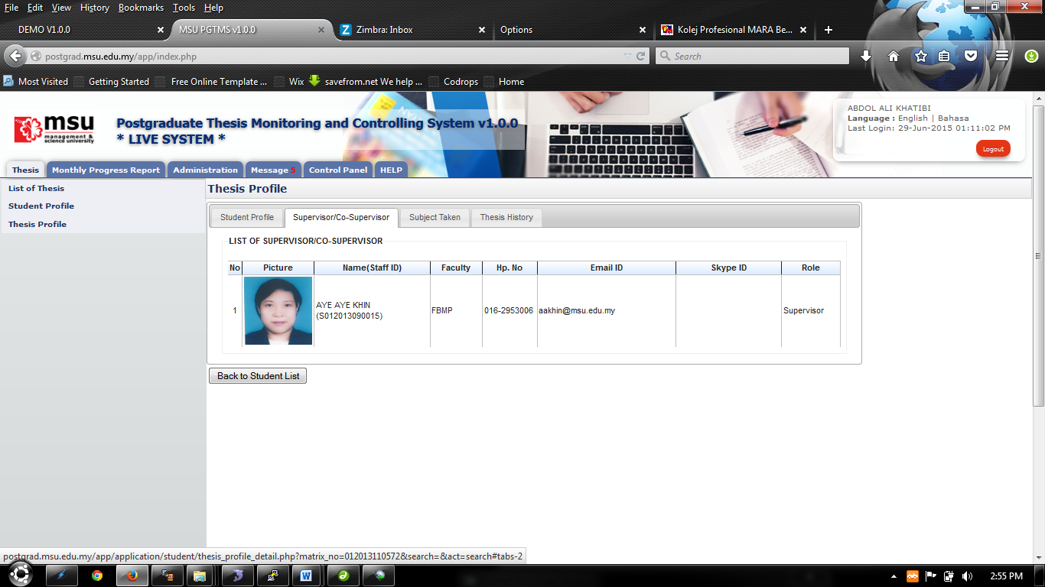

Figure 7: List of Supervisor / Co-Supervisor

**Steps:-**

1. It is only for view information.
2. Click **Back to Student List** button to return back to **Student List** search page

#### Subject Taken

Subject Taken tab will list the entire subject registered by the students for all semester during his study.

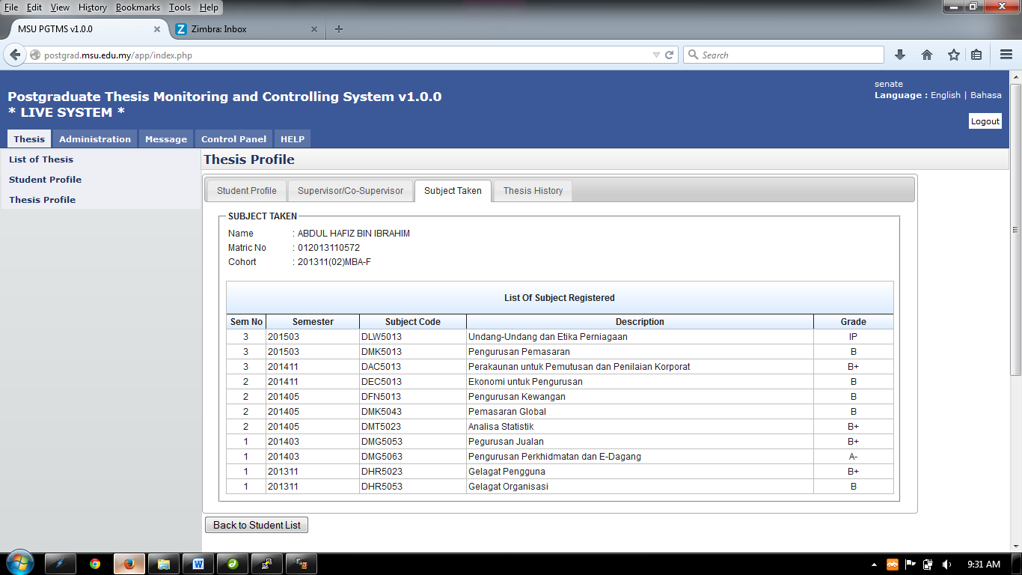

Figure 9: Subject Taken

**Steps:-**

1. It is only for view information.
2. Click **Back to Student List** button to return back to **Student List** search page

#### Thesis History

Thesis History tab contains the proposal progress history starting from its submission by the student till its approval by the Senate.

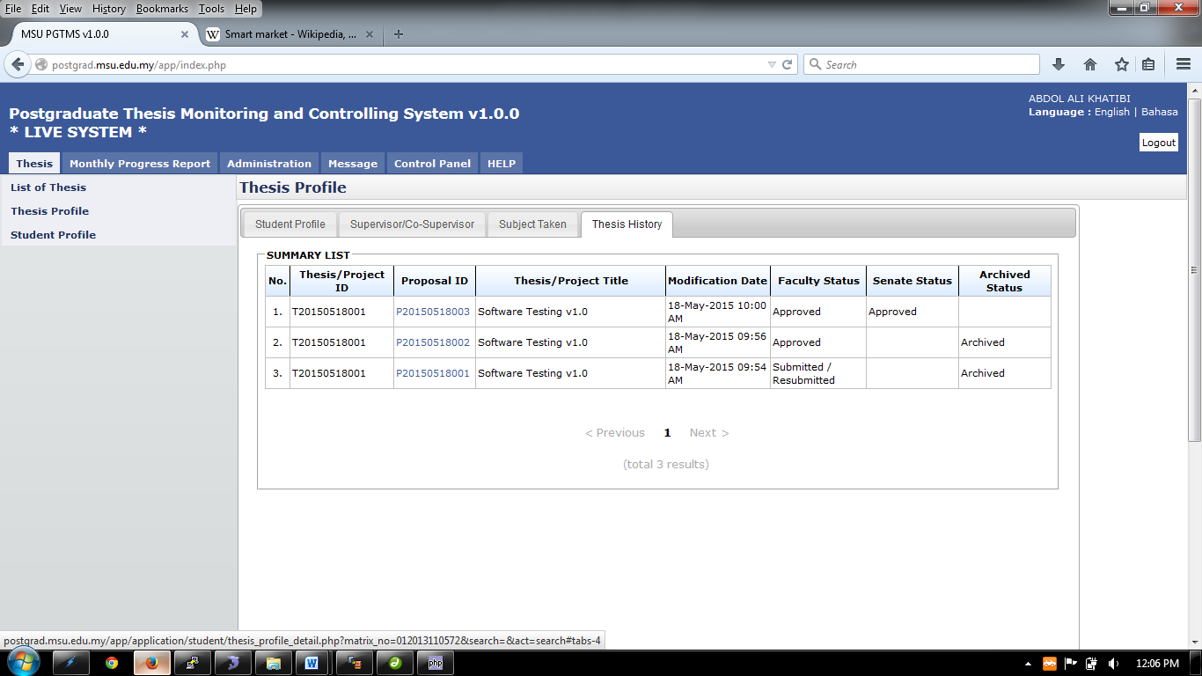

Figure 10: Thesis History

**Steps:-**

1. It is only for view information.
2. Click **Back to Student List** button to return back to **Student List** search page

## Search Student via Student Name/Matrix No

Student profile can be retrieved via student’s **Name** or **Matrix Number**.

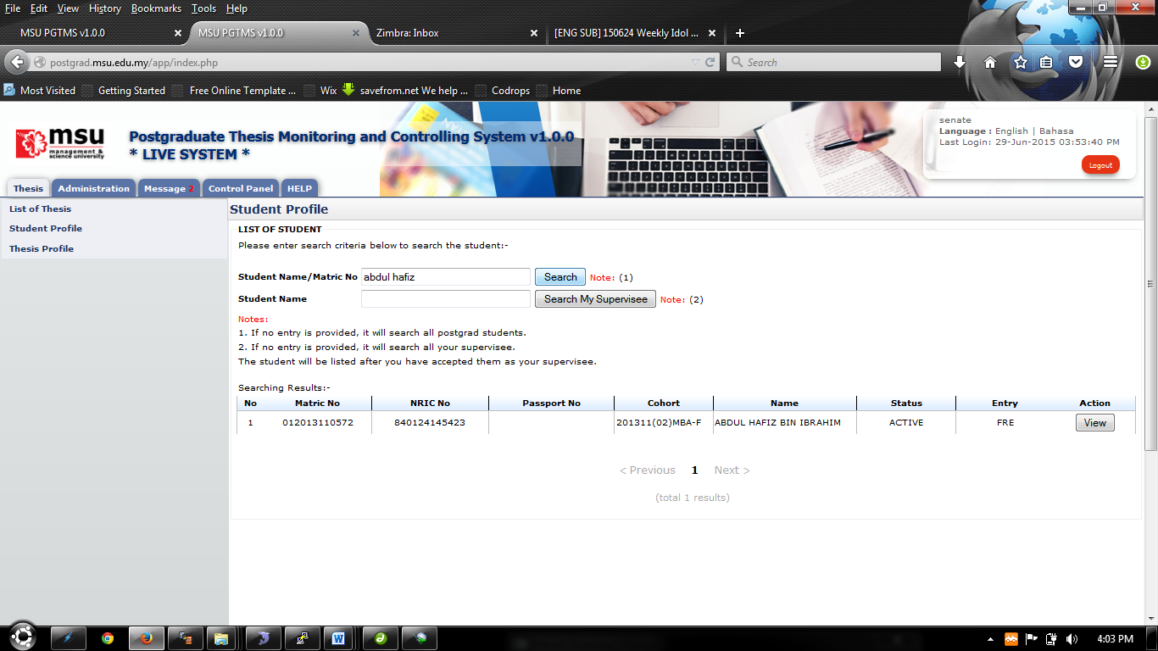

Figure 11: Thesis Tab

**Steps:-**

1. Click on the **Thesis** tab on the system **Top** panel section.
2. The **Student Profile** menu will be displayed on the system **Left** panel and click on it.
3. The searching page will be displayed which the user can search for a particular student in order to view its detail
4. Enter the **Student’s Name** or **Matrix No**. into the field and click on **Search** button to search the student
5. The record will be displayed under the search result.
6. Locate the student from the list and click **View** button to view the profile details

### Student Profile Details

Student Profile will contain all information that related to students which are Student Profile, Supervisor/Co-supervisor lists, Subject Taken and Thesis History.

#### Student Profile

Student Profile tab contains the basic student and thesis information including its thesis progress status



Figure 12: Student Profile

**Steps:-**

1. It is only for view information.
2. Click **Back to Student List** button to return back to **Student List** search page

#### Supervisor/Co-Supervisor List

Supervisor or Co-Supervisor is the academic staff who has been assigned by Faculty to supervise the student in delivering the thesis and approved by the Senate.

There are conditions for the student to see the list of his/her supervisors. The conditions are:-

1. Supervisor/Co-Supervisor has been assigned by Faculty and approved by the Senate
2. Supervisor/Co-Supervisor has accepted the appointment to supervise the student.



Figure 13: List of Supervisor / Co-Supervisor

**Steps:-**

1. It is only for view information.
2. Click **Back to Student List** button to return back to **Student List** search page

#### Subject Taken

Subject Taken tab will list the entire subject registered by the students for all semester during his study.

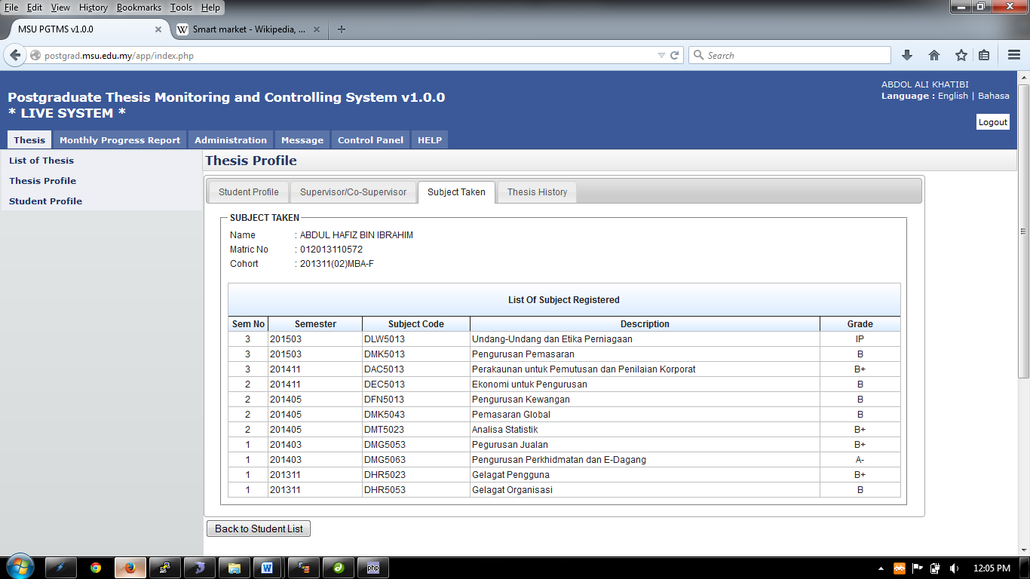

Figure 14: Subject Taken

**Steps:-**

1. It is only for view information.
2. Click **Back to Student List** button to return back to **Student List** search page

#### Thesis History

Thesis History tab contains the proposal progress history starting from its submission by the student till its approval by the Senate. It captures the date of

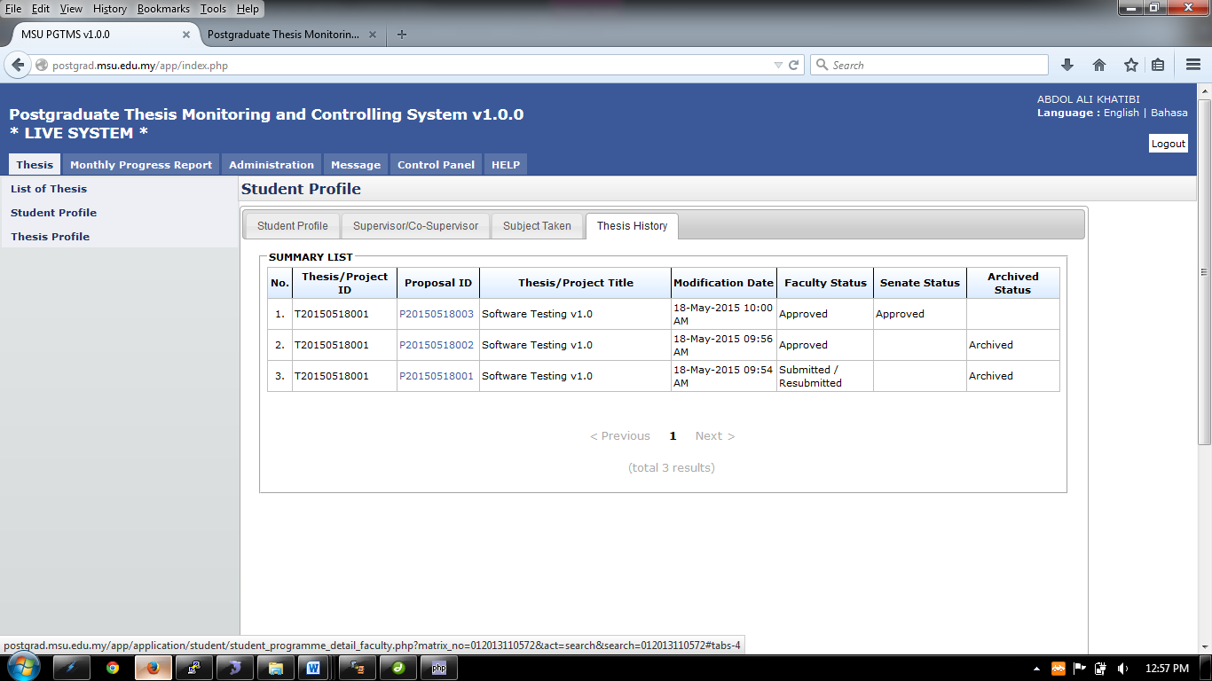

Figure 15: Thesis History

**Steps:-**

1. It is only for view information.

# LIST OF APPROVED THESIS

## List of Approved Thesis

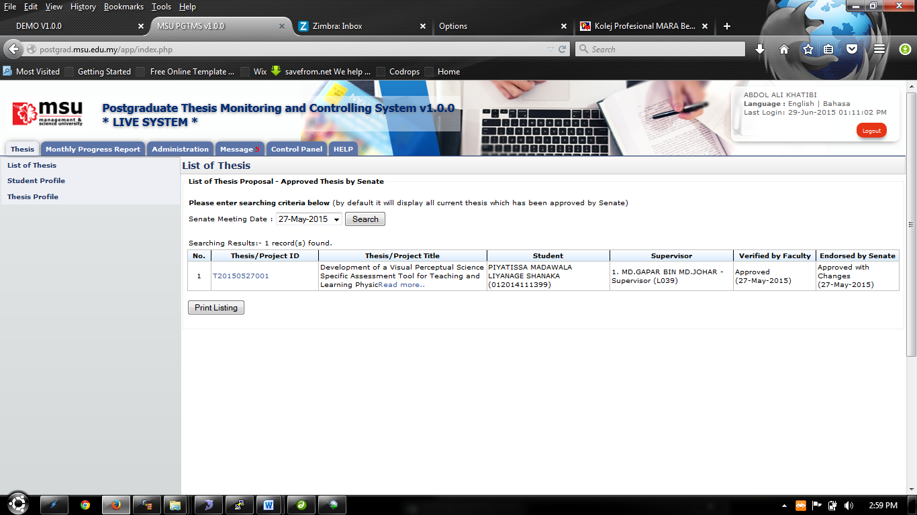

Figure 16: List of Approved Thesis

**Pre-condition**

1. List of thesis approved by senate

**Post-condition**

1. Can proceed to thesis approval

**Steps:-**

1. Click on the **Thesis** tab on the system **Top** panel section.
2. The **List of Thesis** menu will be displayed on the system **Left** panel and click on it.
3. The searching page will be displayed which the user can search for a particular thesis that have been approve by senate in order to view its detail
4. Select the **Senate Meeting Date** at the field and click on **Search** button to search the thesis
5. The record will be displayed under the search result.
6. To print the detail, click **Print Listing** button to proceed.

## Generate File

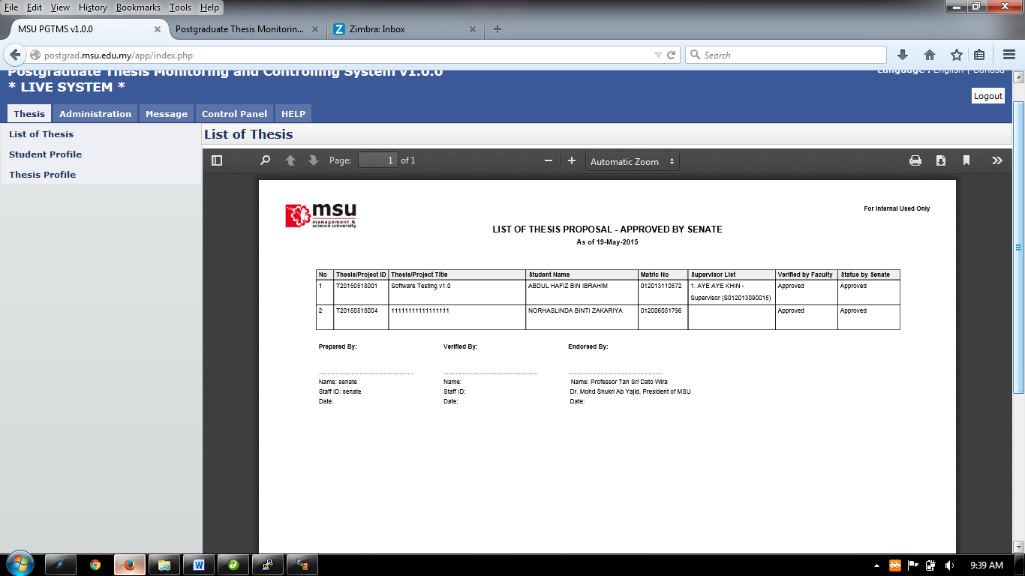

Figure 17: List of Approved Thesis PDF

**Steps:-**

1. To print, click the print logo button 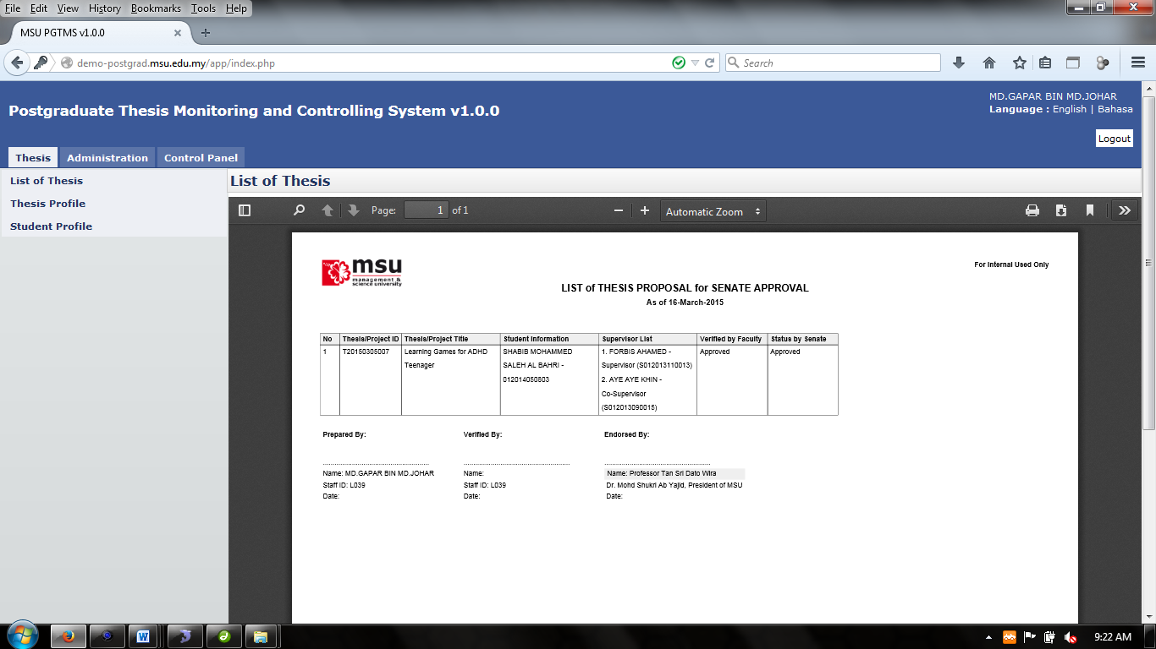 to print.
2. To save file (PDF) click the download logo button 

# ADMINISTRATION VIEW

Administration consists of Thesis Approval and List of Thesis.

## Thesis Approval

All process to approve/disapprove, view, assign or cancelation are being listed on the **Left** panel.

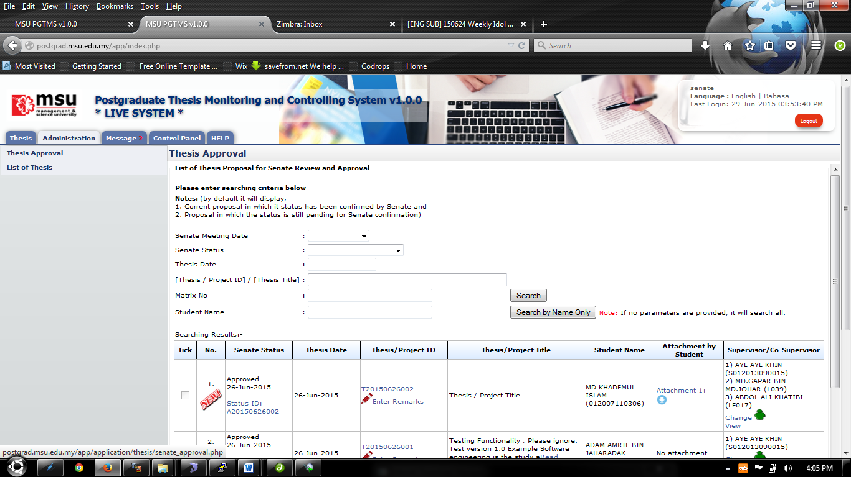

Figure 18: Thesis Approval

**Pre-condition**

1. List of thesis approved or approved with changes by faculty

**Post-condition**

1. Wait for supervisor decision whether to approved or not approved the invitation

**Steps:-**

1. Click on the **Administration** tab on the system **Top** panel section.
2. The **Administration** menu will be displayed on the system **Left** panel and click on it.
3. Click the **Thesis Approval** and the searching page will be displayed which the user can search for a particular thesis for review. It will list the entire thesis that already been approved by the Faculty.
4. Choose the **Senate Meeting Date** or **Senate Status** or **Thesis Date** or by inserting **Thesis ID/Thesis Title** or **Matrix No** all criteria above and click **Search** button.
5. The record will be displayed under the search result.
6. Alternatively,the Thesis Proposal can be searching via **Student Name** by entering the student name.
7. Click **Search by Name Only button** and the record will be displayed under the search result.
8. To change Supervisor/Co-supervisor, click 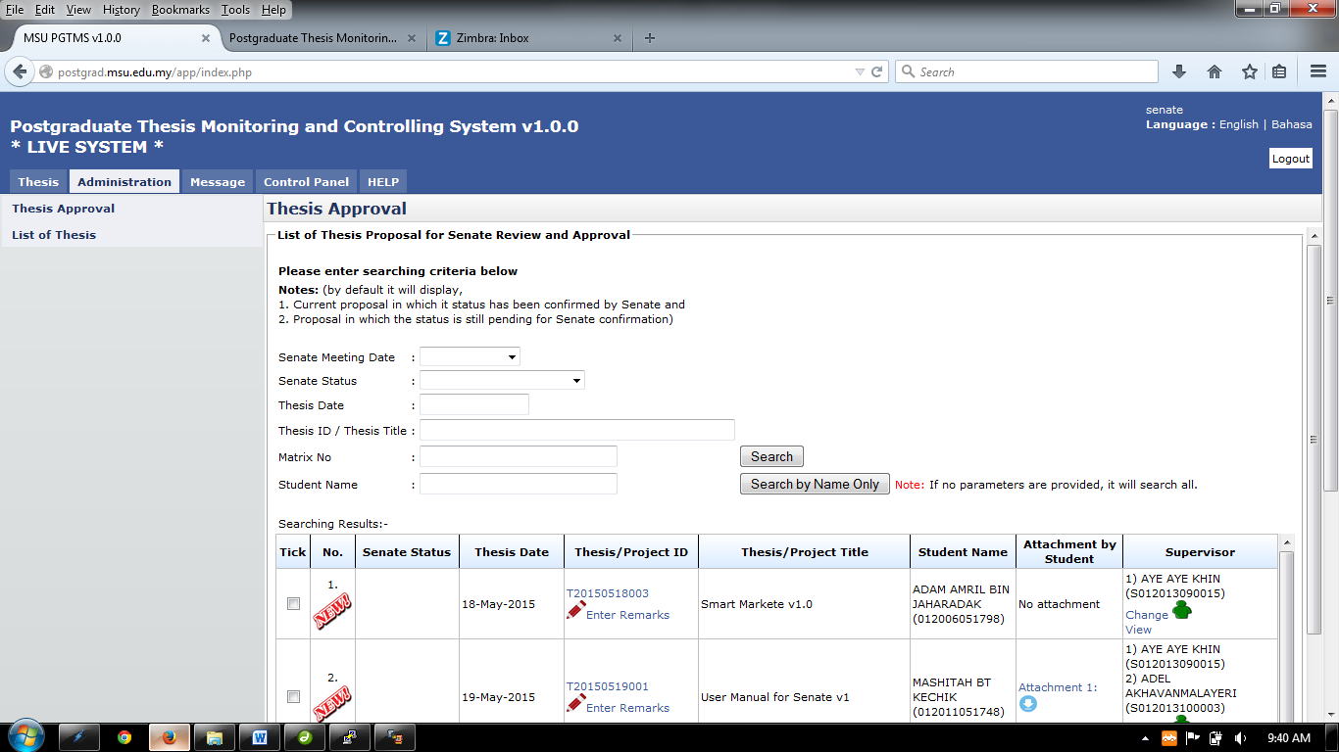. To view Supervisor/Co-supervisor that has been assigned, click .
9. To download and view the attachment that has been uploaded by student, click .

## Thesis Approval – Next Section

### 

Enter overall remark here

Click Here to Change or View Reviewer

Figure 19: Thesis Approval - Searching Result

**Steps:-**

1. The result displays all the thesis/proposal that has been approved by the Faculty.
2. The result will show whether the thesis/proposal is new or not by displaying the icon 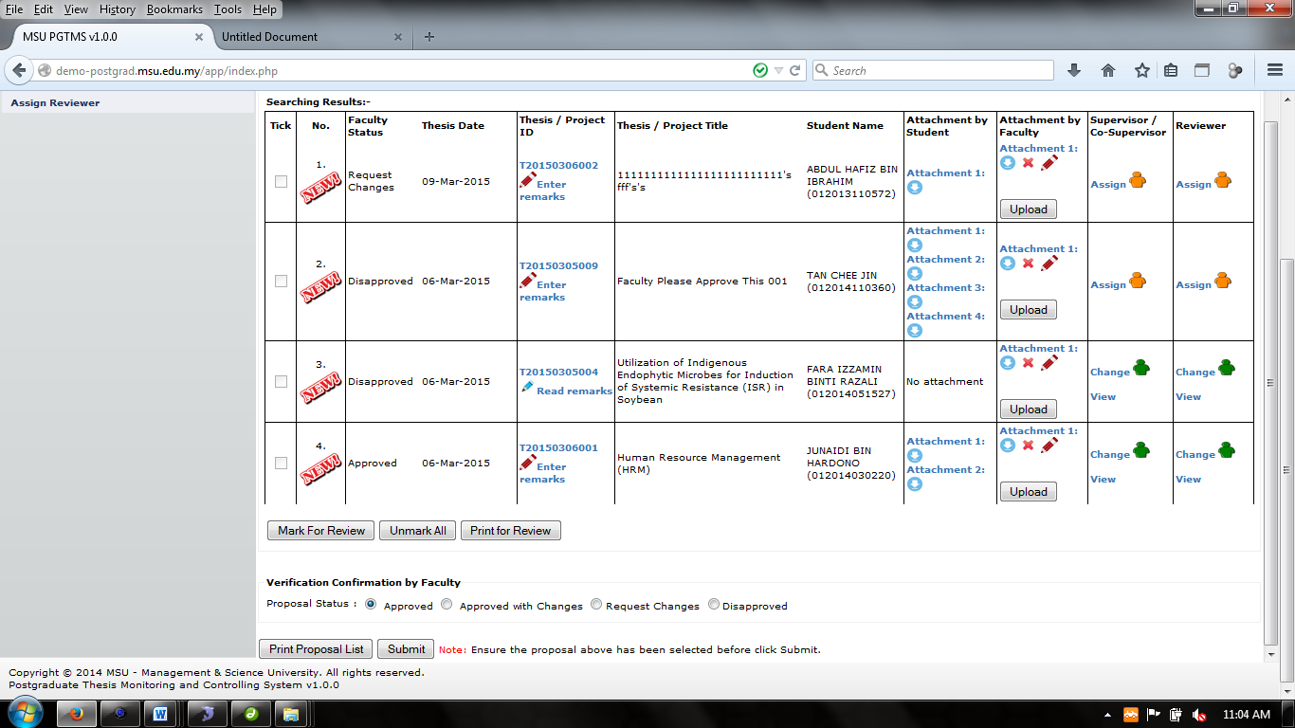 at the **No.** column.
3. To give the remarks, click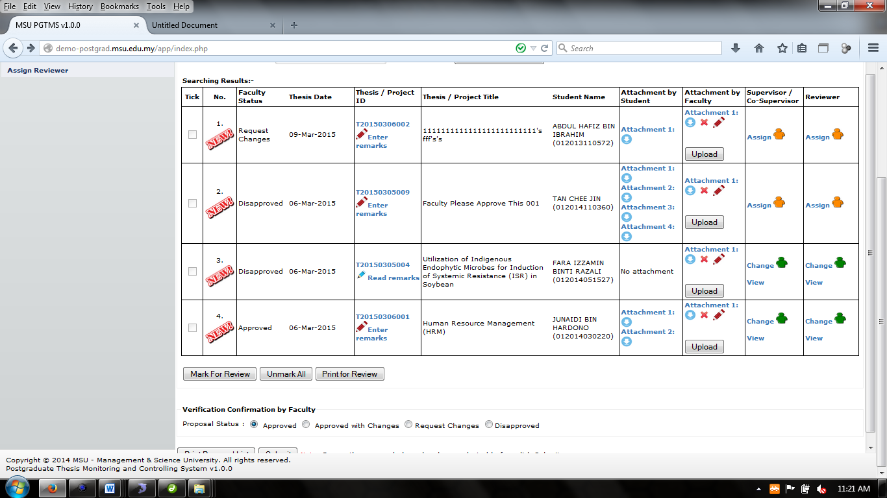to proceed.
4. To read or download attachment uploaded by the student is by clicking the link 
5. To upload attachment, click **Attachment** button.
6. To edit description of the file/attachment, click **Attachment** button.
7. To change Supervisor/Co-supervisor, click the link .
8. To view Supervisor/Co-supervisor that has been assigned, click the link .
9. To confirm the decision of the thesis proposal, tick the proposal and choose the approval status i.e. Approved, Approved with Changes or Disapprove
10. To give overall remark, enter the remark into the field.
11. Then click the **Submit** button to proceed.
12. When **Submit** button is clicked, the email notification will be sent to the student and faculty by the system (Refer Appendix). Plus, email notification will also be sent to the supervisor that has been assigned.
13. To print the proposal list, click **Print Proposal List.**

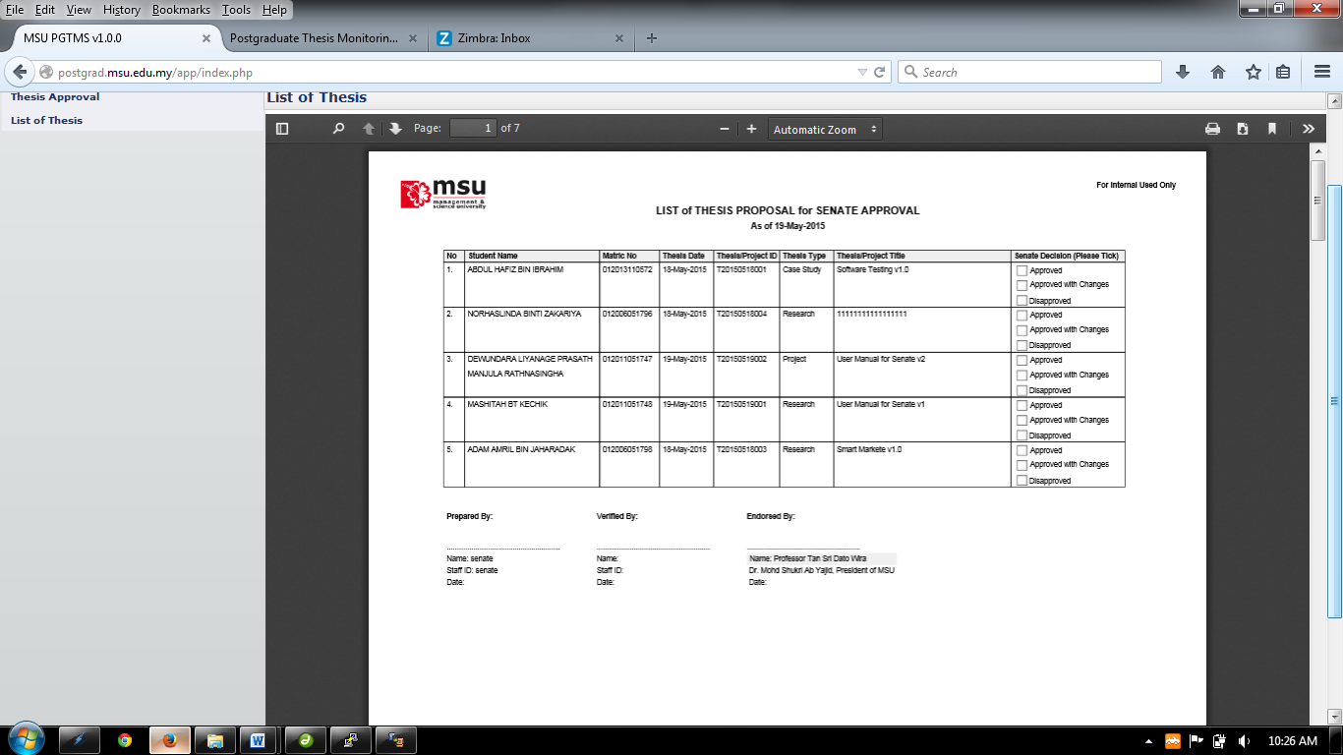

Figure : List of Thesis for Senate Approval PDF

**Steps:-**

1. To print, click the print logo button  to print.
2. To save file (PDF) click the download logo button.

### Enter Remark

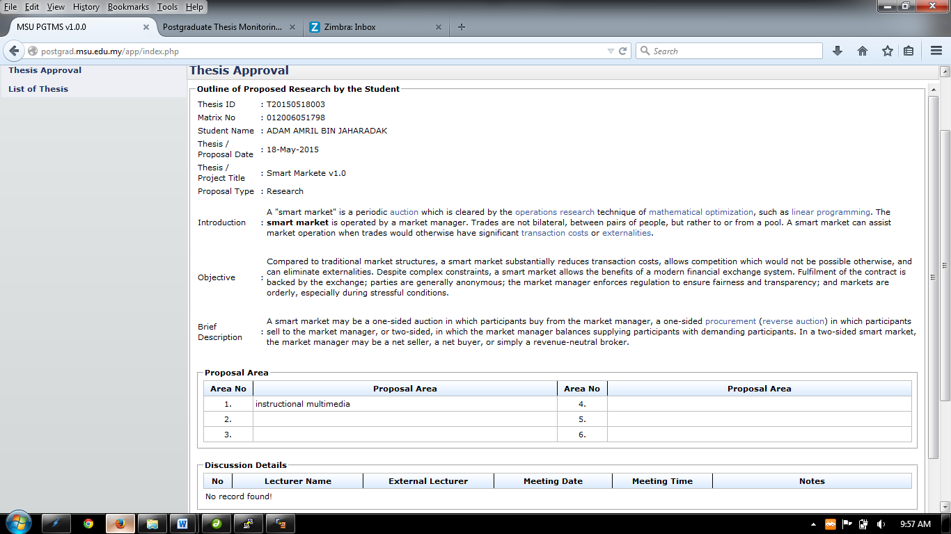

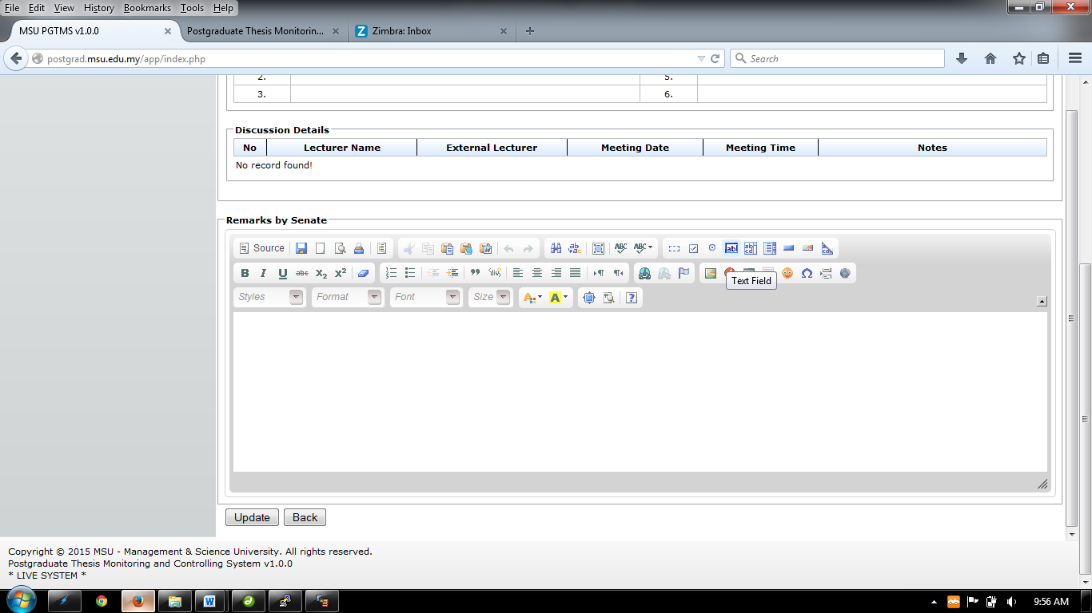

Figure : Remarks by Senate

**Steps:-**

1. This page displays the thesis proposal outline that has been submitted by the student.
2. Enter the necessary remark and click the **Update** button to proceed.
3. Click **Back** button to return to previous page.

### Change and View Supervisor/Co-supervisor

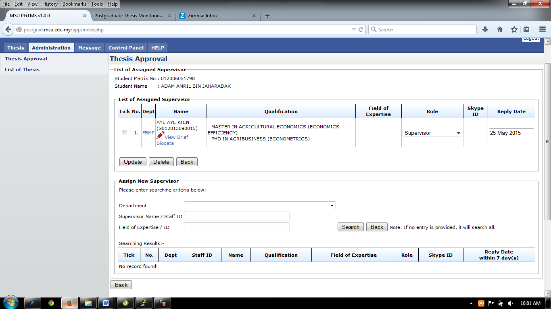

Figure : Change Supervisor/Co-Supervisor

**Steps:-**

1. To assign new Supervisor/Co-supervisor, provide the searching criteria and search. The searching can be by individually or combine. The fields are as follow:-
   1. **Department**
   2. **Supervisor Name / Staff ID**
   3. **Field of Expertise / Expertise ID**
2. If there is no entry provided, the search will display all the staff.

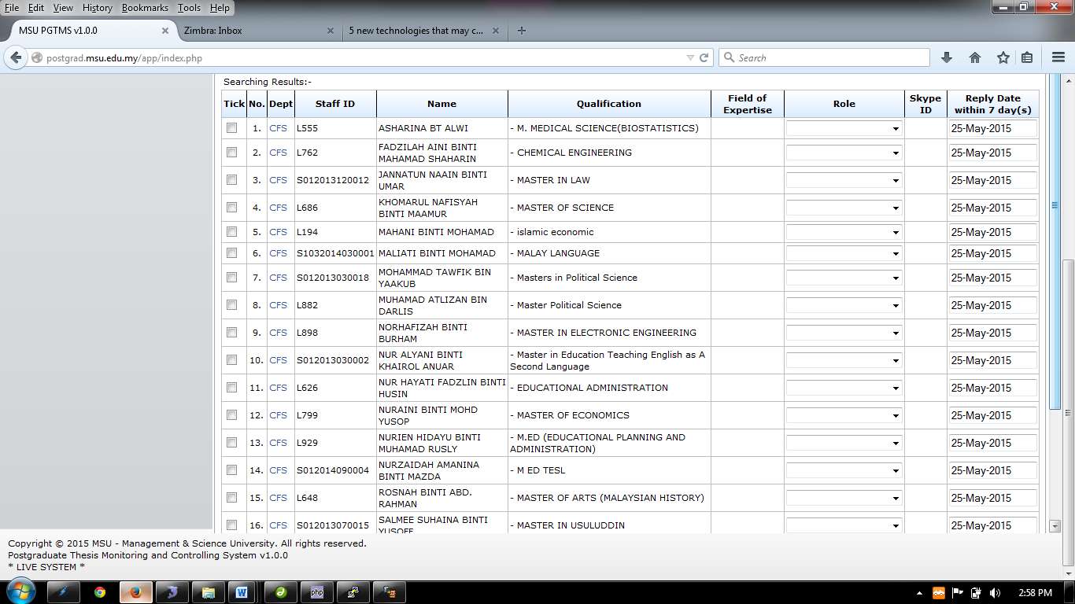

Figure : Search Result with no searching criteria provided

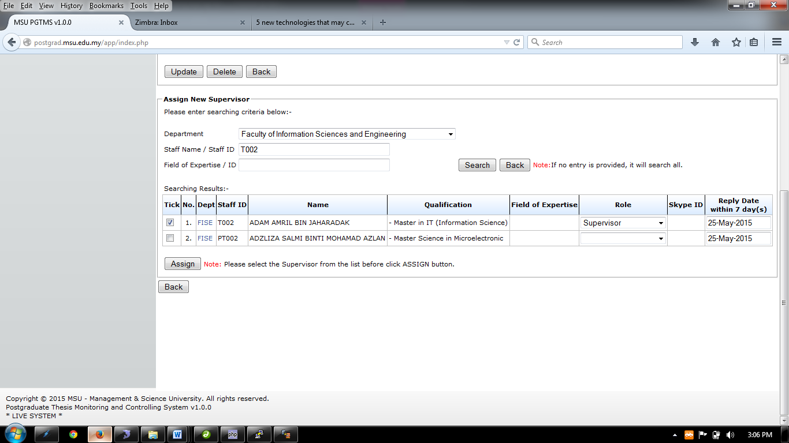

Figure : Search Result with searching criteria provided

1. Choose the staff that the user wants to assign by ticking the checkbox.
2. Then choose the role of the assigned staff whether to be Supervisor or Co-Supervisor.
3. Then choose the **Reply Date**
4. Once done, click **Assign** button.

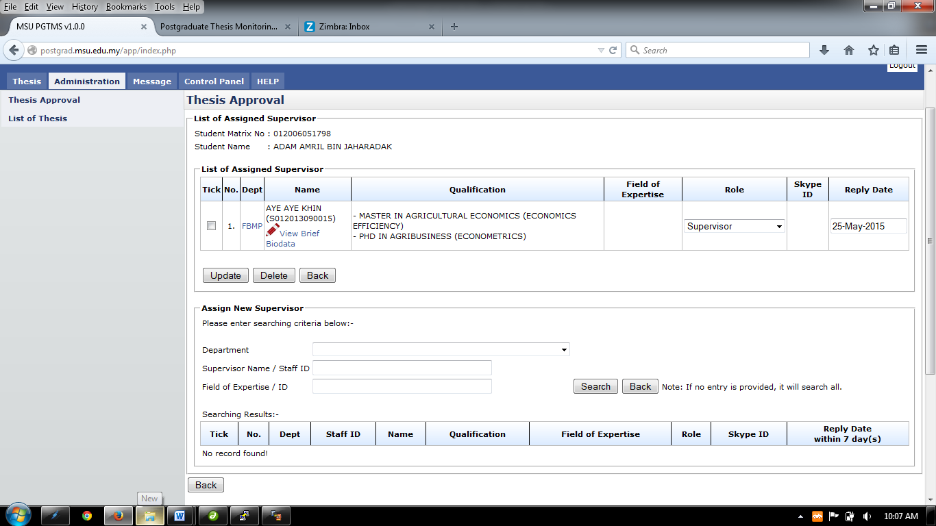

Figure : List of Assigned Supervisor

1. If to delete the assigned Supervisor / Co-Supervisor, tick the checkbox and click **Delete** button to remove the assigned supervisor/co-supervisor from the list.
2. To View brief biodata of the staff click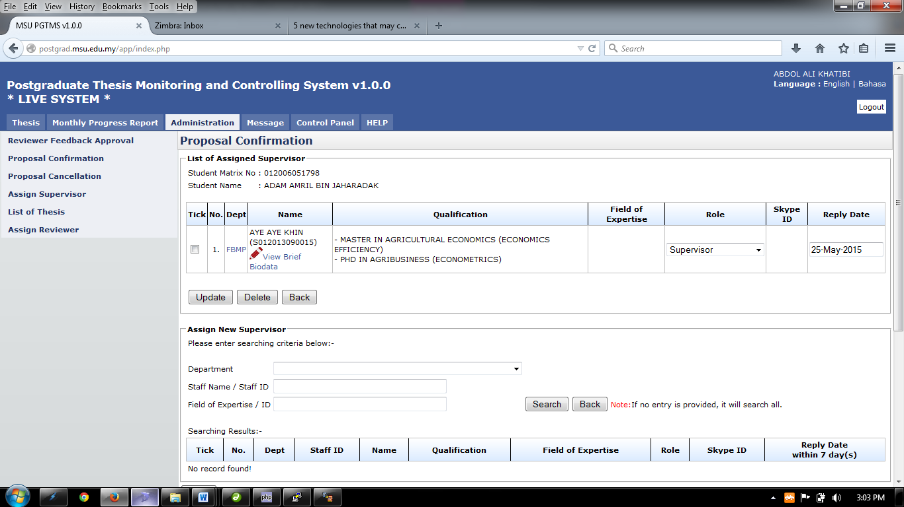.
3. To change the role, choose the **Role** listed or to change the reply date, choose the **Reply Date.** Once done click **Update** button to save it.

#### View Brief Biodata

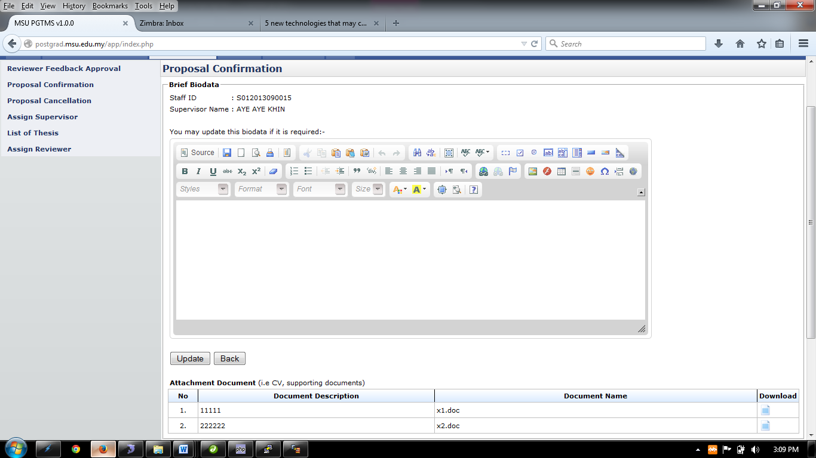

Figure : View and Update Supervisor Biodata

**Steps:-**

1. Insert necessary description into the **Biodata** and then click **Update** button
2. To download necessary document such as supporting document, click  to download.
3. Then click **Back** button.

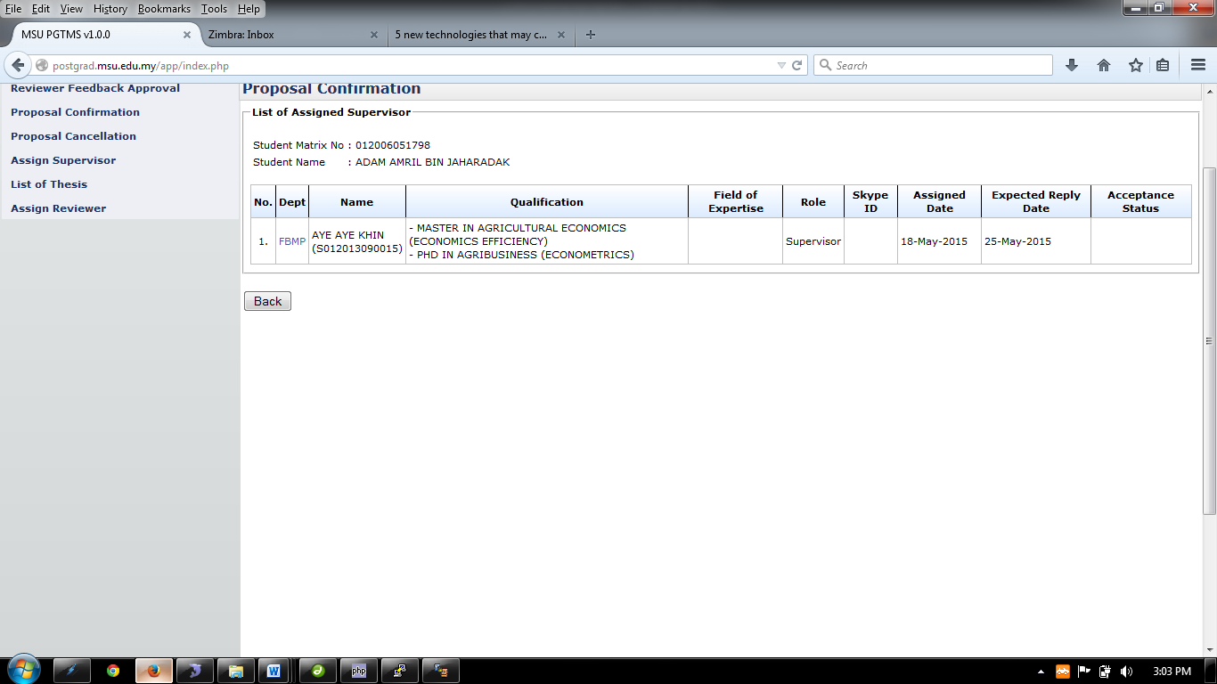

Figure : View Supervisor Assigned

**Steps:-**

1. This page only displays the assigned supervisor/co-supervisor.
2. Then click **Back** button.

### Upload Attachment

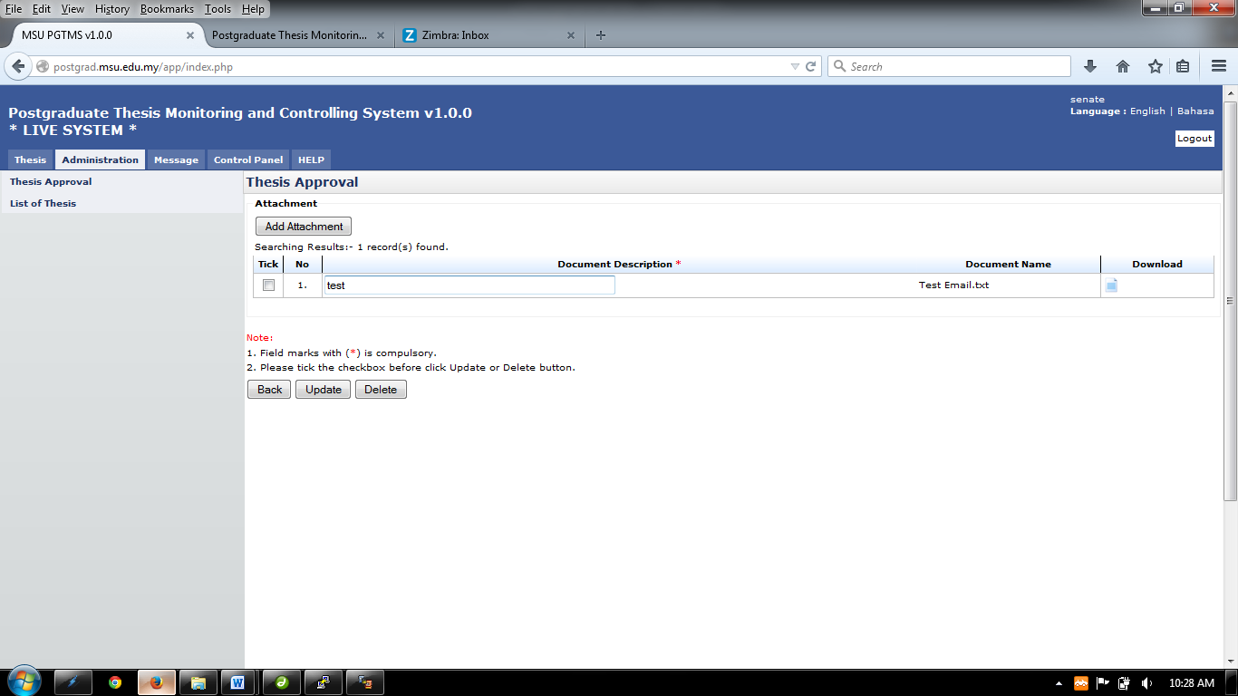

Figure : Upload Attachment

**Steps:-**

1. To upload attachment, click **Add Attachment**
2. To update attachment description, click on the field on the column **Document Description** and insert necessary description.
3. Then tick the checkbox on the left side and click **Update** button.
4. To delete attachment, tick the checkbox on the left and click **Delete** button.
5. To download or read the file that been upload, click 

## List of Thesis Proposal – Disapproved Thesis by Senate

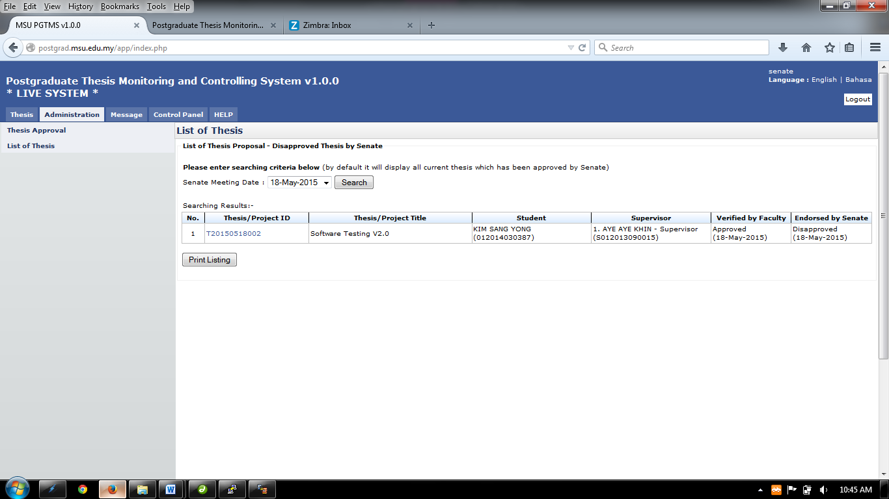

Figure : List of Thesis proposal - Disapproved

**Pre-condition**

1. List of thesis disapproved by senate

**Post-condition**

1. Can proceed to thesis approval

**Steps:-**

1. Click on the **Administration** tab on the system **Top** panel section.
2. The **Administration** menu will be displayed on the system **Left** panel and click on **List of Thesis**.
3. The searching page will be displayed which the user can search for a particular thesis that have been disapproved by senate in order to view its detail
4. Select the **Senate Meeting Date** at the field and click on **Search** button to search the thesis
5. The record will be displayed under the search result.
6. To print the detail, click **Print Listing** button to proceed.

## Generate File

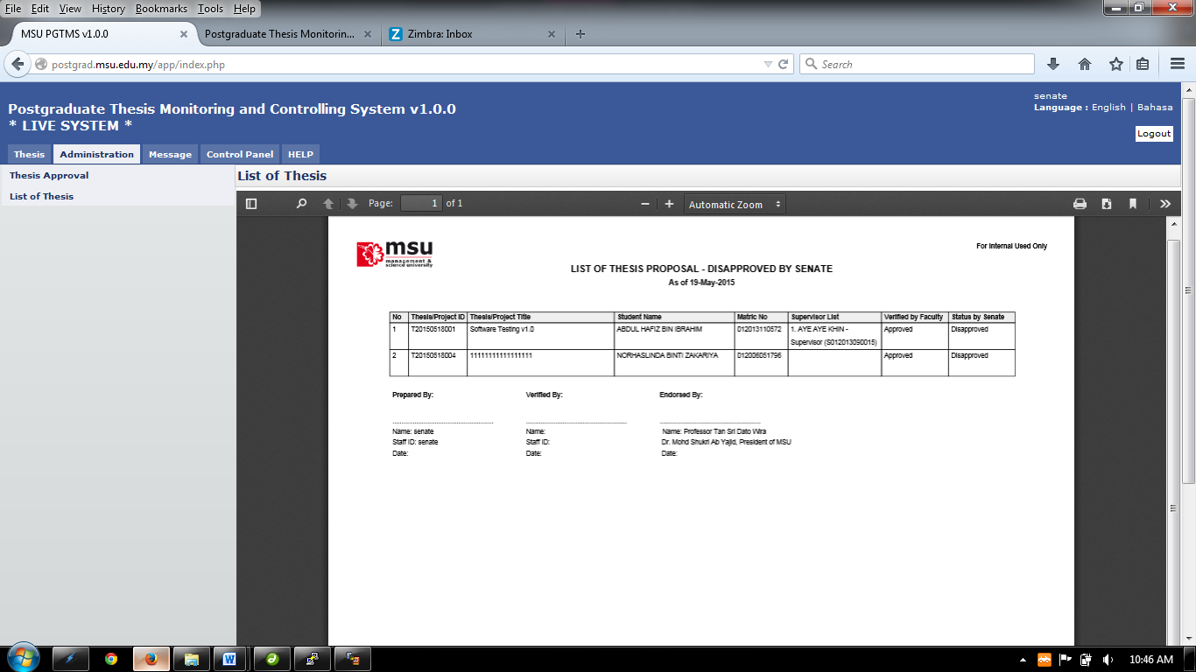

Figure : List of Disapproved Thesis by Senate

**Steps:-**

1. To print, click the print logo button  to print.
2. To save file (PDF) click the download logo button 

APPENDIX

# Email Template - Admin to Student (Trigger after Decision Made by Senate)

## Thesis Proposal - Approved

To: [kimsangyong@msu.edu.my](mailto:kimsangyong@msu.edu.my) <[kimsangyong@msu.edu.my](mailto:kimsangyong@msu.edu.my)>

From: [postgradadmin@msu.edu.my](mailto:postgradadmin@msu.edu.my) <Postgrad Admin>

Subject: Thesis Proposal by KIM SANG YONG – Approved



|  |  |
| --- | --- |
| Dear KIM SANG YONG, |  |
| Please be informed, your thesis proposal has been approved by the Senate. |  |
|  |  |

|  |  |
| --- | --- |
| **Student Name** | KIM SANG YONG |
| **Matric No** | 012014030387 |
| **Submit date** | 19-May-2015 |
|  |  |
| **Thesis ID** | T20150519001 |
| **Thesis/Project Title** | Testing Postgrad System v1.0 (PLEASE IGNORE THIS EMAIL) |
| **Thesis Type** | Research |
| **Senate Status** | Approved |

Thank you,

Best Regards,

Management & Science University

Please do not reply directly to this email. © MSU 2015All rights reserved.  
  
Management & Science University.  
University Drive, Off Persiaran Olahraga,  
Section 14, 40100 Shah Alam,  
Selangor Darul Ehsan.

## Thesis Proposal - Disapproved

To: [kimsangyong@msu.edu.my](mailto:kimsangyong@msu.edu.my) <[kimsangyong@msu.edu.my](mailto:kimsangyong@msu.edu.my)>

From: [postgradadmin@msu.edu.my](mailto:postgradadmin@msu.edu.my) <Postgrad Admin>

Subject: Thesis Proposal by KIM SANG YONG – Disapproved



|  |  |
| --- | --- |
| Dear KIM SANG YONG, |  |
| Please be informed, your thesis proposal has been approved by the Senate. |  |
|  |  |

|  |  |
| --- | --- |
| **Student Name** | KIM SANG YONG |
| **Matric No** | 012014030387 |
| **Submit date** | 19-May-2015 |
|  |  |
| **Thesis ID** | T20150519001 |
| **Thesis/Project Title** | Testing Postgrad System v1.0 (PLEASE IGNORE THIS EMAIL) |
| **Thesis Type** | Research |
| **Senate Status** | Disapproved |

Thank you,

Best Regards,

Management & Science University

Please do not reply directly to this email. © MSU 2015All rights reserved.  
  
Management & Science University.  
University Drive, Off Persiaran Olahraga,  
Section 14, 40100 Shah Alam,  
Selangor Darul Ehsan.

## Thesis Proposal – Approved with Changes

To: [kimsangyong@msu.edu.my](mailto:kimsangyong@msu.edu.my) <[kimsangyong@msu.edu.my](mailto:kimsangyong@msu.edu.my)>

From: [postgradadmin@msu.edu.my](mailto:postgradadmin@msu.edu.my) <Postgrad Admin>

Subject: Thesis Proposal by KIM SANG YONG – Approved with changes



|  |  |
| --- | --- |
| Dear KIM SANG YONG, |  |
| Please be informed, your thesis proposal has been approved by the Senate. |  |
|  |  |

|  |  |
| --- | --- |
| **Student Name** | KIM SANG YONG |
| **Matric No** | 012014030387 |
| **Submit date** | 19-May-2015 |
|  |  |
| **Thesis ID** | T20150519001 |
| **Thesis/Project Title** | Testing Postgrad System v1.0 (PLEASE IGNORE THIS EMAIL) |
| **Thesis Type** | Research |
| **Senate Status** | Approved with Changes |

Thank you,

Best Regards,

Management & Science University

Please do not reply directly to this email. © MSU 2015All rights reserved.  
  
Management & Science University.  
University Drive, Off Persiaran Olahraga,  
Section 14, 40100 Shah Alam,  
Selangor Darul Ehsan.

# Email Template - Admin to Faculty (Trigger after Decision Made by Senate)

## Thesis Proposal - Approved

To: [gsm@msu.edu.my](mailto:gsm@msu.edu.my) <[gsm@msu.edu.my](mailto:gsm@msu.edu.my)>

From: [postgradadmin@msu.edu.my](mailto:postgradadmin@msu.edu.my) <Postgrad Admin>

Subject: Thesis Proposal by MASHITAH BT KECHIK – Approved



|  |  |
| --- | --- |
| Dear Sir, |  |
| Please be informed, the following student thesis proposal has been approved by the Senate. |  |
|  |  |

|  |  |
| --- | --- |
| **Student Name** | MASHITAH BT KECHIK |
| **Matric No** | 012011051748 |
| **Submit date** | 19-May-2015 |
|  |  |
| **Thesis ID** | T20150519002 |
| **Thesis/Project Title** | Testing Postgrad System v2.0 (PLEASE IGNORE THIS EMAIL) |
| **Thesis Type** | Research |

Thank you,

Best Regards,

Management & Science University

Please do not reply directly to this email. © MSU 2015All rights reserved.  
  
Management & Science University.  
University Drive, Off Persiaran Olahraga,  
Section 14, 40100 Shah Alam,  
Selangor Darul Ehsan.

## Thesis Proposal - Disapproved

To: [gsm@msu.edu.my](mailto:gsm@msu.edu.my) <[kimsangyong@msu.edu.my](mailto:kimsangyong@msu.edu.my)>

From: [postgradadmin@msu.edu.my](mailto:postgradadmin@msu.edu.my) <Postgrad Admin>

Subject: Thesis Proposal by MASHITAH BT KECHIK – Disapproved



|  |  |
| --- | --- |
| Dear Sir, |  |
| Please be informed, the following student thesis proposal has been approved by the Senate. |  |
|  |  |

|  |  |
| --- | --- |
| **Student Name** | MASHITAH BT KECHIK |
| **Matric No** | 012011051748 |
| **Submit date** | 19-May-2015 |
|  |  |
| **Thesis ID** | T20150519002 |
| **Thesis/Project Title** | Testing Postgrad System v2.0 (PLEASE IGNORE THIS EMAIL) |
| **Thesis Type** | Research |

Thank you,

Best Regards,

Management & Science University

Please do not reply directly to this email. © MSU 2015All rights reserved.  
  
Management & Science University.  
University Drive, Off Persiaran Olahraga,  
Section 14, 40100 Shah Alam,  
Selangor Darul Ehsan.

## Thesis Proposal – Approved with Changes

To: [gsm@msu.edu.my](mailto:gsm@msu.edu.my) <[kimsangyong@msu.edu.my](mailto:kimsangyong@msu.edu.my)>

From: [postgradadmin@msu.edu.my](mailto:postgradadmin@msu.edu.my) <Postgrad Admin>

Subject: Thesis Proposal by MASHITAH BT KECHIK – Disapproved



|  |  |
| --- | --- |
| Dear Sir, |  |
| Please be informed, the following student thesis proposal has been approved by the Senate. |  |
|  |  |

|  |  |
| --- | --- |
| **Student Name** | MASHITAH BT KECHIK |
| **Matric No** | 012011051748 |
| **Submit date** | 19-May-2015 |
|  |  |
| **Thesis ID** | T20150519002 |
| **Thesis/Project Title** | Testing Postgrad System v2.0 (PLEASE IGNORE THIS EMAIL) |
| **Thesis Type** | Research |

Thank you,

Best Regards,

Management & Science University

Please do not reply directly to this email. © MSU 2015All rights reserved.  
  
Management & Science University.  
University Drive, Off Persiaran Olahraga,  
Section 14, 40100 Shah Alam,  
Selangor Darul Ehsan.

# Email Template - Admin to Supervisor (Trigger after Decision Made by Senate)

## Invitation as Supervisor/Co-Supervisor

To: [aakhin@msu.edu.my](mailto:aakhin@msu.edu.my) <[aakhin@msu.edu.my](mailto:aakhin@msu.edu.my)>

From: [postgradadmin@msu.edu.my](mailto:postgradadmin@msu.edu.my) <Postgrad Admin>

Subject: Thesis Proposal by MASHITAH BT KECHIK – Appointment as Supervisor



|  |  |
| --- | --- |
| Dear Dr. AYE AYE KHIN, |  |
| Please be informed, the following student has submitted his/her thesis proposal for our approval. On behalf of senate, we would like to extend an invitation to you to serve as a Supervisor for the PhD thesis of the following candidate. |  |
|  |  |

|  |  |
| --- | --- |
| **Student Name** | MASHITAH BT KECHIK |
| **Matric No** | 012011051748 |
| **Submit date** | 19-May-2015 |
| **Thesis ID** | T20150519002 |
| **Thesis/Project Title** | Testing Postgrad System v2.0 (PLEASE IGNORE THIS EMAIL) |
| **Thesis Type** | Research |

Thank you,

Best Regards,

Management & Science University

Please do not reply directly to this email. © MSU 2015All rights reserved.  
  
Management & Science University.  
University Drive, Off Persiaran Olahraga,  
Section 14, 40100 Shah Alam,  
Selangor Darul Ehsan.

This page is intentionally left blank.